# **Crane Operator Signals and Safety**

Cranes are tremendously powerful equipment that can lift heavy loads on construction sites. That said, cranes are also potential hazards, as both cranes themselves and the loads they carry can cause harm when improperly handled.

An important part of safely using cranes is communication between the operator and the spotter (person directing the crane’s action and load it is lifting). Having a random set of hand signals that may make perfect sense to the spotter could be lost to the operator. An example would be the spotter frantically waving their hands in the air. Perhaps the spotter is trying to tell the operator to stop, or it could be interpreted by the operator the spotter is trying to swat away a bee. You see the potential for a problem here – don’t you?

There are universal signals that are used for proper crane operations. Keep this OSHA-approved sheet as a resource guide in the cab of any lifting equipment you may use for a quick refresher on proper signals. The operator and spotter should review the signals before the lift to understand what is being requested (spotter) and what is delivered (operator).

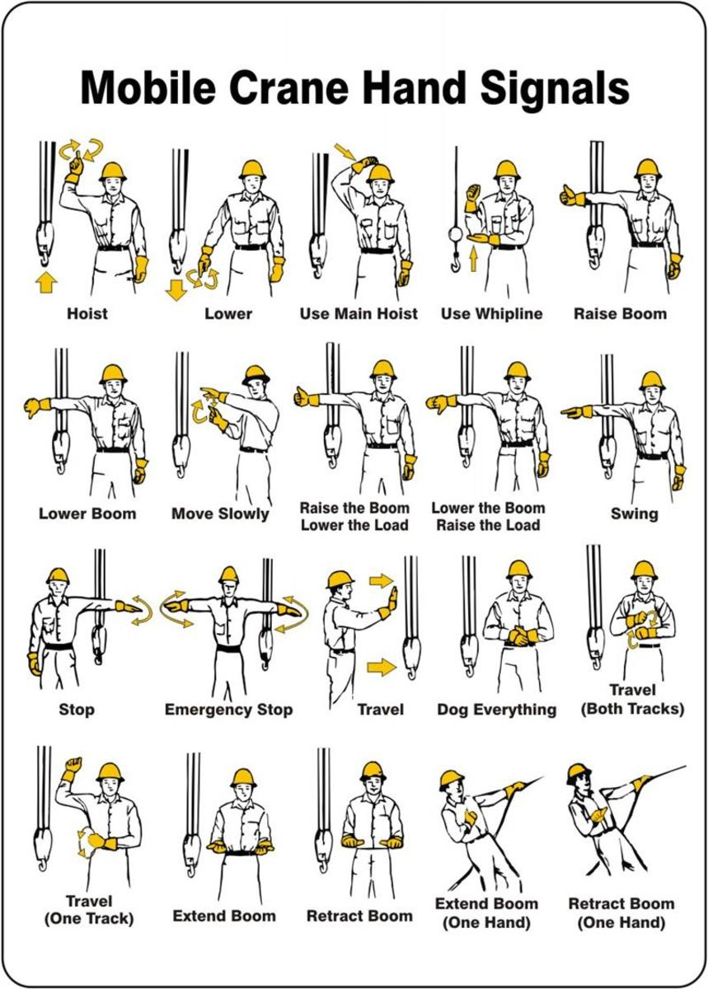

Source: ANSI/ASME B30.5-2007 Mobile and Locomotive Cranes, Section 5-3.3: Signals